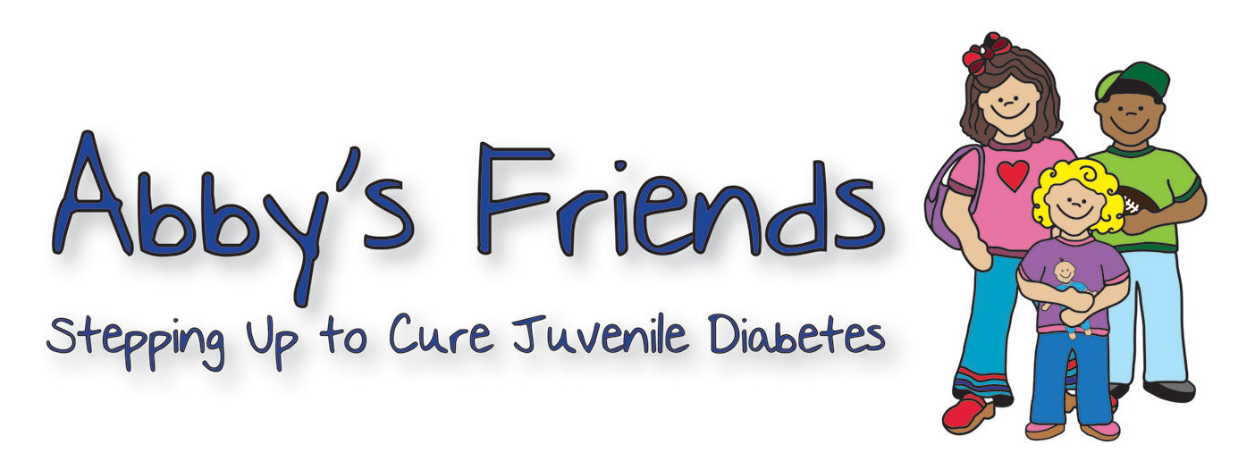

**Charity Golf Classic & Evening Gala**

**Event Date:** August 2, 2013 **Please Return Form By:**  July 5, 2013

**Fax To:** 843.377.8118 **Email To:** abbysfriends@homesc.com

**Mail To:** 295 Seven Farms Drive, Suite C-164, Daniel Island, SC 29492

**Tax ID # 77-0667706** Donations are tax deductible to the extent permitted by law.

**PLEASE PROVIDE DONOR INFORMATION** (As it will appear in auction catalogue):

Donor/Organization Name ____________________________________________________________

Contact Name (if different from above) __________________________________________________

Address ___________________________________________________________________________

City/State __________________________________________ Zip ___________________________

Phone ____________________________________ Fax ____________________________________

Email _____________________________________________________________________________

Web Address _______________________________________________________________________

Item Description ____________________________________________________________________

___________________________________________________________________________________

___________________________________________________________________________________

Special Instructions (limit 6 people, expiration date, etc.) ____________________________________

___________________________________________________________________________________

___________________________________________________________________________________

Gift Certificate attached: ______________ Form may be used as official Certificate: ______________

Value of Donation $______________

Signature___________________________________________________________________________

**Thank you for your support of Abby’s Friends and our mission to find a cure for Juvenile Diabetes.**

|  |  |  |
| --- | --- | --- |
|  |  |  |